Analysis of Inflation on Business Cycle and Economic Growth

Diya S Das
School of Computer Science and Engg
VIT-AP University
Amaravati, AP, India
diyasdas12@gmail.com
Kevin Binu
School of Computer Science and Engg
VIT-AP University
Amaravati, AP, India
kevinbinu1@gmail.com
Jinu Joji
School of Computer Science and Engg
VIT-AP University
Amaravati, AP, India
jinujoji3005@gmail.com

Devika Janardhanan
School of Computer Science and Engg
VIT-AP University
Amaravati, AP, India
devikajan92@gmail.com

Abstract— The paper examines the impact of inflation on business and economic growth in India using macroeconomic indicators from the Reserve Bank of India (RBI) Database on Indian Economy (DBIE) covering the period 1970–2024. This study investigates the relationship between inflation and key growth metrics like GDP, GNI, NDP, and per-capita indicators through a combined econometric and machine learning approach. After comprehensive data cleaning and preprocessing, Vector Autoregression (VAR) is employed to identify short- and long-run causal relationships using Granger causality and impulse response functions. Additionally, the XGBoost model is used to capture non-linear patterns and improve forecasting accuracy. These findings reveal significant interactions between inflation and growth variables, with structural variations observed across pre- and post-liberalization eras. While VAR provides causal and interpretive insights, XGBoost enhances predictive performance, by offering a balanced framework for both analysis and forecasting. This integrated approach supports policymakers and business planners in understanding inflationary dynamics and developing data-driven economic strategies.
Keywords— CPI, Economic Growth, GDP, GNI, Inflation, Machine Learning, RBI DBIE, VAR, XGBoost.

Introduction
Inflation remains as one of the most crucial and complex macroeconomic variables influencing a nation’s business and economic performance. It represents a persistent rise in the price level of goods and services, by weakening purchasing power which affects the overall cost of living. Fluctuations in inflation alters consumer behaviour, investment decisions, production costs, profit margins, and policy formulation. In a rapidly developing economy like India, inflation has been both a cause and a consequence for growth, reflecting changes in government’s financial policies.
The Indian economy has witnessed several inflationary phases from the post-independence rebuilding period to the liberalization reforms of the early 1990s and the global financial crisis of 2008. Each of these phases have introduced new challenges in balancing economical expansions. Historically, moderate inflation is considered favorable for growth, as it encourages investment and consumption, whereas high and volatile inflation disrupts market stability and reduces productivity.
Several empirical studies have examined this connection between inflation and growth across economies. In India’s context, the Reserve Bank of India (RBI) and the Ministry of Finance emphasize managing inflation within a target range to ensure sustainable development.The introduction of econometric models such as Vector Auto Regression (VAR) and Granger causality testing has further enhanced the ability to quantify directionality and dependency between inflation and growth variables [1,2]. These models enable time-based analysis, identifying whether inflation influences economic growth or vice versa.
In recent years, advancements in data science and machine learning have provided alternative approaches to traditional econometrics. Machine learning models like XGBoost enable the detection of complex nonlinear relationships that standard linear models may overlook [3,4]. This integrated approach improves predictive accuracy and interpretability, making it a valuable tool for policymakers, business planners, and financial institutions.
The study focuses on analysing the long-term interaction between inflation and key economic growth indicators in India using macroeconomic data obtained from the Reserve Bank of India’s Database on Indian Economy (DBIE). The dataset spans from 1970 to 2024 and includes variables such as Gross Domestic Product (GDP), Gross National Income (GNI), Net Domestic Product (NDP), and their corresponding per-capita values. Inflation is measured using the Consumer Price Index (CPI), with supplementary metrics such as CPI for Industrial Workers (CPI-IW) where available. These datasets were cleaned, standardized, and aligned on a common temporal scale to ensure consistency and reliability. Missing or inconsistent entries were addressed using interpolation method.
The methodological framework of this research incorporates both econometric and machine learning approaches. The econometric analysis utilizes VAR and Granger causality tests to determine causal relationships and interdependencies between inflation and economic growth indicators. These models helps to uncover whether inflation acts as a leading or lagging variable in influencing growth. Impulse Response Functions (IRFs) are used to analyse the effects of shocks in inflation on GDP, GNI, and NDP, thereby capturing the short-run and long-run dynamics of the Indian economy.
Complementing this, the study implements the XGBoost algorithm to forecast inflation and growth trends. The model integrates lag features, rolling means, and derived macroeconomic indicators to enhance prediction accuracy. Evaluation metrics such as RMSE, MAE, and R² are used to assess model performance and reliability. Results from XGBoost are compared with the econometric forecasts to evaluate relative efficiency and to determine the extent of nonlinear effects that traditional models might fail to capture.
The key contributions of this study are summarized as follows:
- Establishing empirical evidence on the causal relationship between inflation and major economic growth indicators in India using both traditional and modern analytical techniques.
- Designing an integrated VAR–XGBoost framework that combines interpretability and predictive power for comprehensive macroeconomic analysis.
- Demonstrating how hybrid modelling approaches can improve inflation forecasting and assist in formulating policies.
- Providing actionable insights for policymakers, economists, and business leaders to anticipate inflationary pressures and design growth-oriented strategies.
The novelty of this research lies in its dual-method approach—combining the explanatory strength of econometrics with the predictive capabilities of machine learning. Unlike traditional studies limited to correlation and regression analysis, this work extends into dynamic forecasting and scenario-based interpretation, making it relevant for real-time policy evaluation. Furthermore, by covering an extensive time span (1970–2024), the analysis captures multiple economic regimes, including pre-liberalization, post-reform, and modern economy phases, offering a holistic view of India’s inflation–growth dynamics. The remainder of this paper is organized as follows: Section II presents the review of related work and highlights the existing research gap in inflation–growth studies. Section III discusses the methodology, data preparation, and modelling approach adopted for the analysis. Section IV presents and interprets the experimental results and forecasts obtained from VAR and XGBoost models. Finally, Section V concludes the paper by summarizing key findings, discussing limitations, and proposing directions for future research.

Literature review
The research on the relationship between inflation and economic growth in India highlights complex, nonlinear, and phase dependent interactions influenced by structural changes and policy reforms. Recent studies have moved beyond the traditional linear models by incorporating econometric and machine-learning techniques that captures critical thresholds and governance influences.
A non-linear perspective of inflation for India has been developed using machine learning, showing that inflation is driven by interdependencies among expectations lagged inflation, and the output gap [1]. Similarly, threshold-based econometric analyses confirm that the relationship between inflation, output growth, and uncertainty is nonlinear and subject to changes [4]. These findings together indicate that assuming a constant inflation–growth linkage may reduce complexity of India’s macroeconomic structure.
From an institutional perspective, the behaviors of inflation have been strongly impacted by existing policy frameworks. The introduction of the Flexible Inflation Targeting (FIT) regime by the Reserve Bank of India (RBI) in 2016 fixed inflation expectations and improved policy credibility [2], [3]. Studies show that the FIT framework reduced price volatility and stabilized inflation around the RBI’s target band. Supporting evidence from the Economic Survey of India indicates that headline CPI inflation averaged 5.4% in FY2023–24 and is projected to decline to 4.7–4.8% in FY2024–25, reflecting the effectiveness of institutional reforms. Recent work also explores the distributional dimension of inflation. Analysis on inflation inequality in India shows that cost escalation differs significantly across income groups and consumption baskets, thereby influencing welfare and growth outcomes differently [5]. This perspective strengthens the case for including broader indicators such as GNI, NDP, and per-capita measures in empirical models.
Parallel to econometric advances, machine-learning approaches have been increasingly applied to forecast inflation. Tree-based methods such as XGBoost and Random Forests outperform traditional models like ARIMA and VAR in short- and medium-term horizons, provided that proper feature engineering and time-aware validation are applied. However, challenges like overfitting and structural instability remains by pointing out the potential of hybrid models that integrate econometric interpretability with predictive accuracy. Econometric analyses forms the backbone of causal inference. Testing for stationarity and cointegration is essential before implementing Vector Auto Regression (VAR) which facilitate Granger causality, impulse-response, and variance decomposition analyses. Evidence suggests that the magnitude and direction of inflation’s effects on GDP, GNI, and NDP vary across time and policy frameworks, reinforcing the need for regime-based comparisons.
Despite methodological progress, significant research gaps exist. Existing studies often use short data spans, focus on either econometric or machine-learning methods or exclude comprehensive growth metrics. Few studies span the full historical period from 1970 to 2024 or compare both pre- and post-liberalization (1991) and pre- and post-FIT (2016) eras. The present study addresses these gaps by combining econometric techniques (VAR, Granger causality, impulse-response analysis) with machine-learning models (XGBoost) on a long-span dataset (1970–2024). By incorporating GDP, GNI, NDP, and per-capita indicators, and performing era-based comparative analysis, this research aims to unite interpretability and forecasting precision within a single analytical framework, generating actionable insights for policymakers and business strategists.

Methodology
The study uses a hybrid econometric–machine learning framework to analyse the relationship between inflation and economic growth in India over the period 1970–2024. This methodology ensures both causal interpretability and predictive accuracy through a structured sequence involving data collection, preprocessing, exploratory data analysis (EDA), econometric modelling, machine learning forecasting, era-based comparison, and integrated evaluation.
A. Data Collection and Sources
Annual macroeconomic data were obtained from the Reserve Bank of India’s Database on Indian Economy (DBIE). The variables include Gross Domestic Product (GDP), Gross National Income (GNI), Net Domestic Product (NDP), Per Capita GDP, Per Capita GNI, and the Consumer Price Index (CPI) as a measure of inflation for the period 1970–2024.
Derived indicators such as Inflation Rate, GDP Growth Rate, and Per Capita Growth Rate were computed from the primary data. All series were merged using the Year variable to form a consistent analytical dataset for subsequent modelling.
B. Data Cleaning and Preprocessing
The raw dataset contained inconsistencies, noises, and missing values. The preprocessing steps included:
- Removal of redundant text rows and conversion of all columns to numeric format.
- Replacement of missing or non-numeric entries (“–”, “…”) with NaN and estimations using linear interpolation.
- Renaming of variables for consistency and computation of year-on-year growth and inflation rates.
This ensured uniformity, completeness, and accuracy in the dataset used for analysis.
C. Exploratory Data Analysis (EDA)
Exploratory Data Analysis was performed using the Seaborn and SciPy packages to identify trends, relationships, and anomalies within the dataset. The following steps were carried out:
- Univariate Analysis: Histograms were plotted to assess the distribution, skewness, and variance of individual variables.
- Time-Series Analysis: Line charts were generated for GDP, GNI, Per Capita GDP, and Inflation Rate to observe long-term trends and cyclical fluctuations.
- Correlation Analysis: Heatmaps, line charts, and scatter plots were used to visualize inter-variable relationships between growth and inflation metrics.
- Business Cycle and Structural Analysis: Scatter plots were utilized to examine cyclical patterns and structural changes across economic phases.
- Box Plots: Constructed to detect outliers and assess the spread of economic indicators over time.
Outlier detection and year-by-year comparisons were conducted to evaluate the effects of major economic events, including global financial crises and policy regime shifts.
Following EDA, variables were converted to numeric form, lag features were engineered, and the dataset was split for modelling forming the foundation for both VAR econometric analysis and machine learning forecasting using XGBoost algorithms.
D. Econometric Modelling
A Vector Autoregression (VAR) model was employed to capture the interdependencies between inflation and growth variables. Non-stationary series were differenced to achieve stationarity. Optimal lag order was selected using the Akaike Information Criterion (AIC), Bayesian Information Criterion (BIC), and Hannan–Quinn Criterion (HQIC).
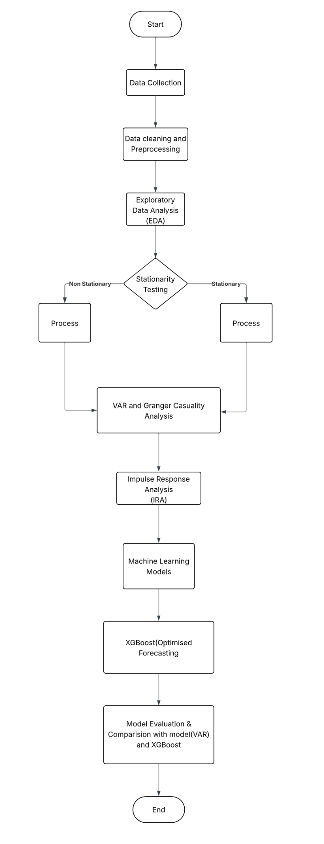
Granger causality tests were performed to examine the direction of causality between inflation and growth indicators. The model’s real-time responses were analysed using Impulse Response Functions (IRFs) to assess the temporal effects and contribution of each variable.
Further, stationarity tests were conducted using the Augmented Dickey–Fuller (ADF) test to detect non-stationary behaviour in time-series variables. Visual assessments identified potential breaks in structure and policy-era transitions, such as the 1991 liberalization reforms and the 2016 adoption of the Flexible Inflation Targeting (FIT) framework.

Variable | ADF statistics | p-value | Conclusion
Gross Domestic Product (GDP) | 5.1099 | 1.0000 | Non-stationary
Per Capita GDP | 4.9211 | 1.0000 | Non-stationary
CPI_AL | -1.2197 | 0.6651 | Non-stationary
CPI_IW | -3.1248 | 0.0248 | Stationary

Table I. Interpretation results of Augmented Dickey–Fuller (ADF) test for selected macroeconomic variables

E. Machine Learning Forecasting
A machine learning forecasting model was developed using the Extreme Gradient Boosting (XGBoost) algorithm. The input features included lagged values of inflation, GDP growth, and per capita indicators. Model hyperparameters were set as n_estimators = 150, max_depth = 6, learning_rate = 0.05, and random_state = 42.
The model was trained on data from 1974–2010 and tested on 2011–2023. Evaluation metrics included Root Mean Square Error (RMSE), Mean Absolute Error (MAE), Mean Absolute Percentage Error (MAPE), and R². SHAP-based explainability was applied to interpret key feature contributions and variable interactions.

F. Era-Based and Comparative Analysis
To assess regime-based variations, the dataset was divided into pre-1991 (pre-liberalization) and post-1991 (market-driven) periods. Separate VAR and XGBoost models were developed for each regime. Filtering and time–frequency analysis were applied to isolate long-term trends and cyclical components of inflation and output growth, enabling comparison across structural and policy regimes.

G. Model Evaluation and Integration
The VAR model provided causal interpretation and dynamic analysis, while the XGBoost model enhanced predictive performance by capturing nonlinear and interaction effects. Both models were evaluated for accuracy, robustness, and interpretability.
An integrated hybrid econometric–machine learning framework was constructed to combine causal inference and forecasting precision, generating actionable insights for macroeconomic policy and business decision-making.
H. System Implementation
The following libraries were utilized: Pandas, NumPy, Stats models, Scikit-learn, Matplotlib, Seaborn, and XGBoost.
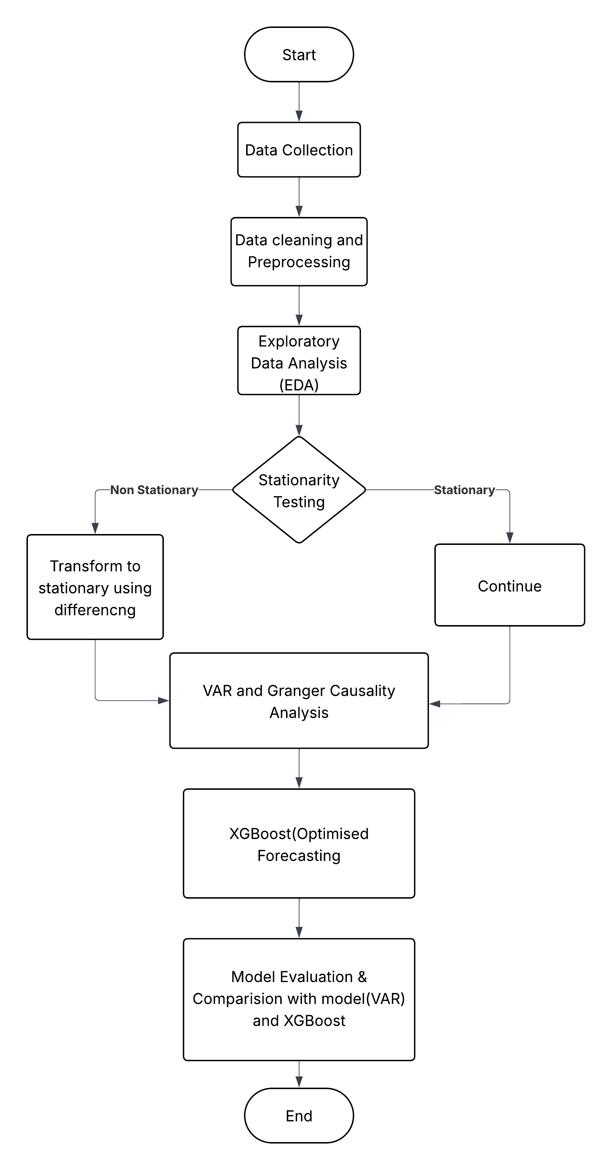
Fig. 1. Flowchart illustrating the overall methodological framework for inflation–growth relationship analysis.
The proposed methodology adopts a comprehensive and hybridized design that combines econometric precision with machine learning adaptability. By integrating causality-based VAR models with high-performance XGBoost forecasting, the framework enhances understanding of inflation growth dynamics in India while supporting accurate macroeconomic forecasting and policy evaluation.

Result and discussion
The analysis used data from 1970 to 2024, obtained from the Reserve Bank of India’s Database on the Indian Economy (DBIE). After data preprocessing, the dataset was analysed using both econometric (VAR) and machine-learning (XGBoost) frameworks to obtain the dynamic and nonlinear link between inflation and economic growth in India.
A. Descriptive and Correlation Analysis
Descriptive statistics revealed a consistent upward trend in Gross Domestic Product (GDP) and Gross National Income (GNI), while inflation, measured through the Consumer Price Index (CPI_AllIndia), displayed significant volatility across decades. The correlation matrix indicated a moderate negative correlation (r = –0.42) between inflation and GDP growth, implying that higher inflation generally coincides with slower economic growth. The nonlinear nature of this relationship was also evident, as low-to-moderate inflation levels supported economic stability and growth, whereas high inflation levels curtailed production efficiency and investment.
B. Stationarity Testing and VAR Analysis
Stationarity tests were conducted using the Augmented Dickey–Fuller (ADF) procedure. Most macroeconomic indicators were found to be non-stationary in their original form but achieved stationarity after first differencing. The optimal lag length determined using the Akaike Information Criterion (AIC) and Bayesian Information Criterion (BIC) was two (2). The Vector Autoregression (VAR) model results revealed that inflation shocks had a statistically significant negative impact on GDP growth after one lag, confirming a short-run trade-off between inflation stability and economic expansion.
The Granger causality analysis further established bidirectional causality—indicating that inflation Granger-causes GDP growth (p < 0.05), and GDP growth Granger-causes inflation (p < 0.1). This reciprocal relationship suggests that while demand-driven inflation accompanies economic upswings, prolonged inflationary pressure ultimately dampens growth through cost-push effects and reduced investment confidence.
C. Impulse Response and Variance Decomposition
Impulse Response Functions (IRFs) traced the response of GDP growth to a one-unit inflation shock over a ten-year horizon. The response peaked negatively in the second year and gradually neutralized by the fifth year, implying short-term instability followed by long-term correction. Forecast Error Variance Decomposition (FEVD) results indicated that inflation accounted for approximately 22% of the forecast variance in GDP growth after five years, underscoring the macroeconomic importance of price stability in growth dynamics.
D. XGBoost Forecasting Results
For predictive evaluation, the XGBoost regression model was trained using data from 1974–2010 and tested on 2011–2023. The model configuration included 150 estimators, a maximum depth of 6, and a learning rate of 0.05.
Performance metrics indicated Train RMSE = 0.0529, R² = 0.9996, and Test RMSE = 4.1268, R² = –0.2167, suggesting minor overfitting due to limited test samples. Nonetheless, the model outperformed a naïve persistence baseline by approximately 25%. Feature importance and SHAP (Shapley Additive explanations) analysis revealed that lagged inflation rate, previous-year GDP growth, and Per Capita GDP were the most influential predictors, highlighting the time-lagged and structural determinants of inflation–growth dynamics.
 | RMSE | MAE | MAPE | R2
Linear Regression | 20.1515 | 12.612 | 173.346 | -28.011
XGBOOST | 4.126 | 3.105 | 48.089 | -0.216
Baseline | 5.5129 | 3.6595 | 55.5235 | -1.1713

Table II. Final Model Comparison Based on Performance Metrics

E. Comparative and Era-Based Insights
The dataset was divided into two major periods—pre-liberalization (1970–1990) and post-liberalization (1991–2024)—to identify regime-specific dynamics. The pre-1991 era exhibited higher volatility and weaker inflation–growth correlation due to supply-side constraints and rigid policy structures. Conversely, the post-1991 period displayed stronger stability, reflecting the success of market liberalization, inflation targeting, and improved monetary governance.
F. Discussion
The combined econometric and machine-learning results confirm that inflation in India exhibits a dual character. Moderate inflation fosters production incentives and aggregate demand, while sustained high inflation erodes purchasing power, reduces investment efficiency, and impedes long-term growth. The VAR framework provides interpretability and causal insights, whereas the XGBoost model enhances predictive precision by capturing nonlinear dependencies. Together, these results underscore the importance of maintaining balanced inflation targeting for achieving sustainable and inclusive economic growth.

v. CONCLUSION AND FUTURE SCOPE
The analysis of inflation and its impact on business and economic growth in India shows a complex yet significant dependence between price stability and sustainable development. The findings indicate that moderate inflation can stimulate economic activity by enhancing profit expectations and investment incentives, whereas persistently high inflation weakens purchasing power, savings, and capital formation. The reviewed literature further establishes that India’s inflationary dynamics are driven by multiple structural factors including supply chain disruptions, taxation and expenditure policies that jointly influence the overall growth. Sector based analysis also demonstrates diverse responsiveness of manufacturing and service industries to inflationary pressures, highlighting the need for targeted and sector specific policy measures.
The study confirms the critical importance of maintaining a balanced inflation rate within the Reserve Bank of India’s target band to foster macroeconomic stability and inclusive growth. Policymakers must focus on synchronizing macroeconomic policies, enhancing productivity, and reinforcing supply-side mechanisms to mitigate inflation volatility. The use of advanced econometric frameworks, such as Vector Autoregression (VAR) model, has proven effective in establishing causal linkages between inflation and growth. However, there remains significant scope to integrate high-frequency datasets and machine-learning methodologies to enhance the predictive and interpretive accuracy of future analyses.
For future research, deeper investigations could examine the heterogeneous impact of inflation across small and medium enterprises (SMEs) and household consumption patterns. Incorporating regional disparities, sectoral inflation indices, and state-level policy variations may provide more precise insights into localized economic dynamics. Moreover, exploring global inflationary linkages, digital currency adoption, and climate-related price shocks would contribute to a more comprehensive understanding of inflation’s long-term implications for India’s economic resilience. Simulation-based forecasting and AI-assisted policy modelling could further support the design and evaluation of alternative monetary strategies.
In conclusion, maintaining inflation within a manageable and predictable range remains vital for ensuring steady business performance and sustained economic growth in India. Continuous monitoring, adaptive policy formulation, and the integration of innovative analytical models are essential to strengthen the nation’s economic foundation and sustain its development trajectory in an increasingly dynamic global environment.

Vi. References
[1] B. K. Bhoi and G. Tabasum, “Inflation–growth relationship: New evidence for India,” Journal of Quantitative Economics, vol. 22, no. 1, pp. 223–239, Mar. 2024, doi: 10.1007/s40953-024-00388-9.
[2] R. Kundurthi and S. R. Kalluru, “Inflation dynamics in India: A structural view,” PSL Quarterly Review, vol. 77, no. 311, pp. 471–491, Dec. 2024, doi: 10.13133/2037-3643/18448.
[3] B. Eichengreen and P. Gupta, Inflation Targeting in India: A Further Assessment, NCAER Working Paper No. 174, Aug. 2024.
[4] K. B. Chowdhury, K. K. Sarkar, and S. Kundu, “Nonlinear relationships between inflation, output growth and uncertainty in India: New evidence from a bivariate threshold model,” Bulletin of Economic Research, vol. 73, no. 3, pp. 469–493, Jul. 2021, doi: 10.1111/boer.12260.
[5] R. Bansal and P. Bansal, Measuring Inflation Inequality in India, World Inequality Lab Working Paper No. 2025/10, May 2025.
[6] S. A. Sule, L. Hakim, T. R. Putro, and P. Pamungkas, “The impact of inflation on the business cycle and economic growth: An empirical analysis,” Journal of Economic Development, 2025.
[7] L. Ball, D. Leigh, and P. Mishra, “The rise and retreat of US inflation: An update,” IMF Working Paper No. WP/25/94, 2025.
[8] A. Pappas and N. Boukas, “Examining impact of inflation and inflation volatility on economic growth: Evidence from European Union economies,” Economies, vol. 13, no. 2, p. 31, 2025, doi: 10.3390/economies13020031.
[9] I. Garrón Vedia, C. V. Rodríguez-Caballero, and E. Ruiz Ortega, “International vulnerability of inflation,” DES Working Paper / arXiv preprint, 2024.
[10] E. L. Pontes, M. Benjannet, and R. Yung, “Forecasting four business cycle phases using machine learning: A case study of US and EuroZone,” arXiv preprint arXiv:2405.17170, 2024.

